Step 1:-Go to terminal and run the command ipconfig
IPV4
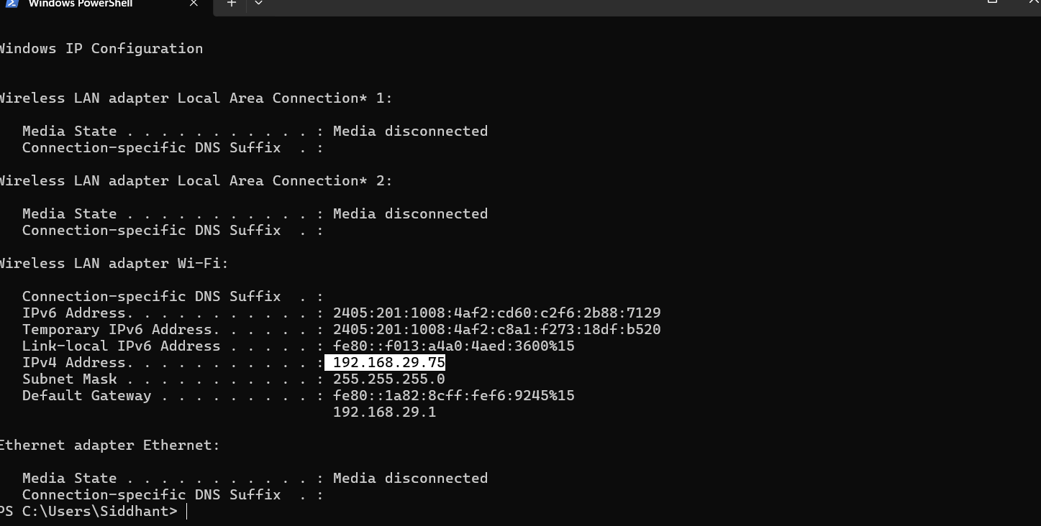

Step 2:-Ensure that the wifi setting must be Private network
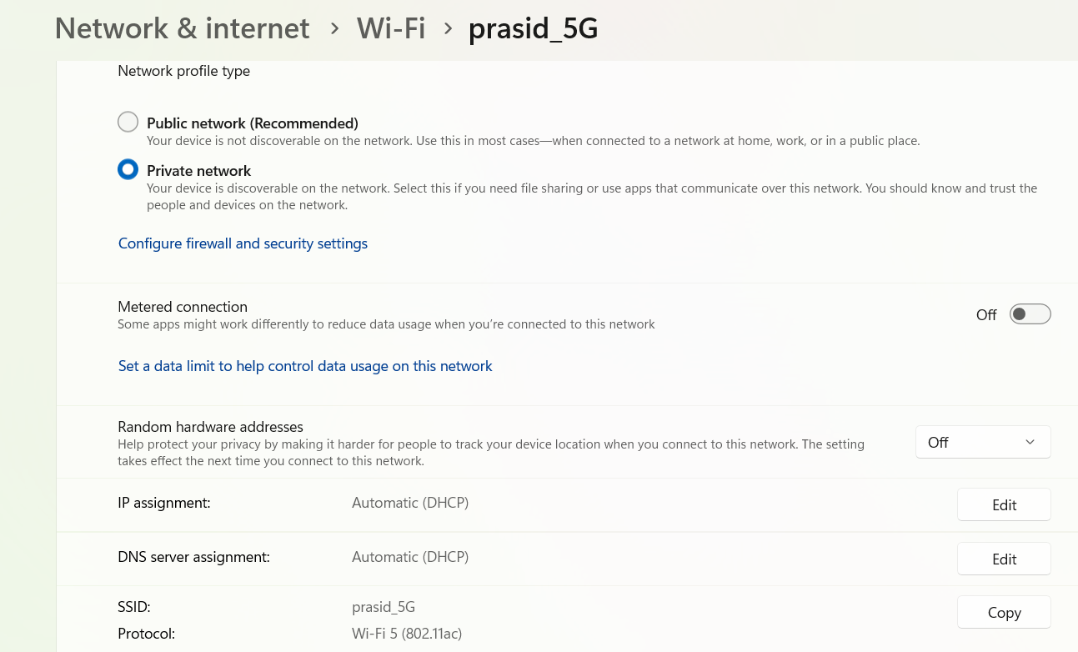

Step 3:-Go to VS code>Search for the LIVE preview settings>Live Preview:Host IP and paste the IPv4 adress(from terminal)
After that restart the VS Code
